Order Of Service

Singing: Psalm 139b—CW page 117

Reading: Psalm 61

Opening Hymn: TLH 604

Reading: Acts 7:17-22

Request Hymn: CW Supplement 716

Reading: John 14:15-24

Sermon Hymn: TLH 611 vs 1-4

Sermon Text: Daniel 1:1-2

The Land of Shinar

Prayer

The Apostles’ Creed, TLH page 12

Holy Communion

The Lord's Prayer

The Blessing

Closing Hymn: TLH 611 vs 5-7

* * * * * * * * * * *

Koinonia Hour

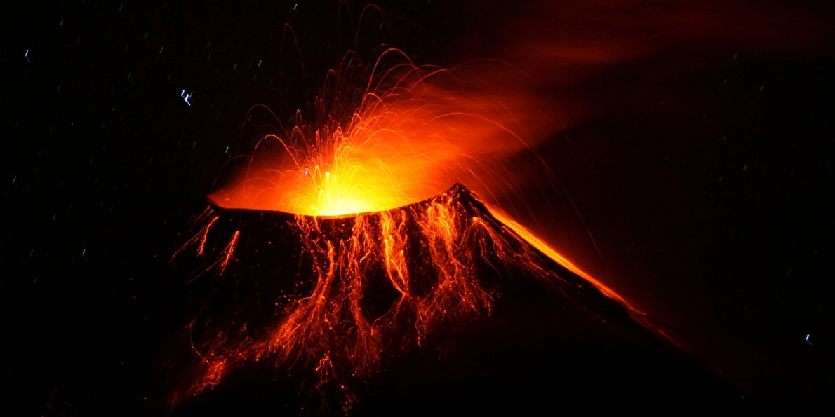

God’s Judgment

Water
Of
Life
5 November 2017

W A T E R O F L I F E

Independent Christian Church—Conservative Lutheran Doctrine

Worship Service: 9:30 a.m. Bible Study: 10:45 a.m.

Larry Cooper, Pastor E-Mail address:
111 N. Ridge Road lcooper@wateroflife.cc
Coon Valley, WI 54623 Web Site:
Phone: (608) 452-2105 www.wateroflife.cc

* * * * * * * * * * * * * * * * * * * * * * * * * * *

Sermon Text: Daniel 1:1-2

The Land of Shinar

* * * * * * * * * * * * * * * * * * * * * * * * * * *

Daniel 1:1 In the third year of the reign of Jehoiakim king of Judah came Nebuchadnezzar king of Babylon unto Jerusalem, and besieged it.
:2 And the Lord gave Jehoiakim king of Judah into his hand, with part of the vessels of the house of God: which he carried into the land of Shinar to the house of his god; and he brought the vessels into the treasure house of his god.

Related Passages: Genesis 10:8-10

8 And Cush begat Nimrod: he began to be a mighty one in the earth.
9 He was a mighty hunter before the LORD: wherefore it is said, Even as Nimrod the mighty hunter before the LORD.
10 And the beginning of his kingdom was Babel, and Erech, and Accad, and Calneh, in the land of Shinar.

Genesis 11:1-9

1 And the whole earth was of one language, and of one speech.
2 And it came to pass, as they journeyed from the east, that they found a plain in the land of Shinar; and they dwelt there.
3 And they said one to another, Go to, let us make brick, and burn them throughly. And they had brick for stone, and slime had they for morter.
4 And they said, Go to, let us build us a city and a tower, whose top may reach unto heaven; and let us make us a name, lest we be scattered abroad upon the face of the whole earth.
5 And the LORD came down to see the city and the tower, which the children of men builded.
6 And the LORD said, Behold, the people is one, and they have all one language; and this they begin to do: and now nothing will be restrained from them, which they have imagined to do.
7 Go to, let us go down, and there confound their language, that they may not understand one another's speech.
8 So the LORD scattered them abroad from thence upon the face of all the earth: and they left off to build the city.
9 Therefore is the name of it called Babel; because the LORD did there confound the language of all the earth: and from thence did the LORD scatter them abroad upon the face of all the earth.

